**May Backpacking**

**Date: May 24-27, 2019**

**Location: Shining Rock Wilderness Area – Canton, NC**

**Cost: $25/person**

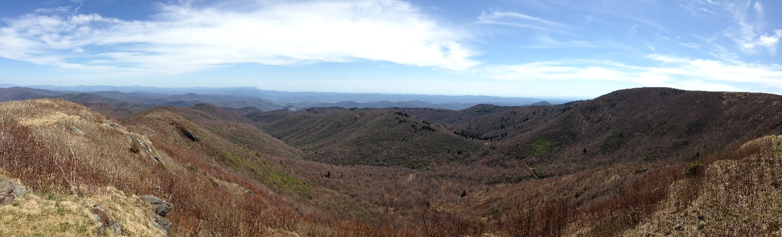

**Itinerary:**

**Friday, May 24:**

* 5:30pm - Leave the church.
* 8:30pm - Arrive at Daniel Boone Scout Camp, Canton, NC.  3 hour drive to the camp.

**Saturday, May 25:**

* Philmont treks head out from Daniel Boone
* Bus to Black Balsam Parking Lot to drop Raven and Medium Treks leaving from there

**Monday, May 27:**

* Pick up everyone at Black Balsam Parking lot. All treks need to return to the parking lot by 10:30am. Lunch served before departing.
* 12:30pm - Leave for home. Return to the church around 4pm.

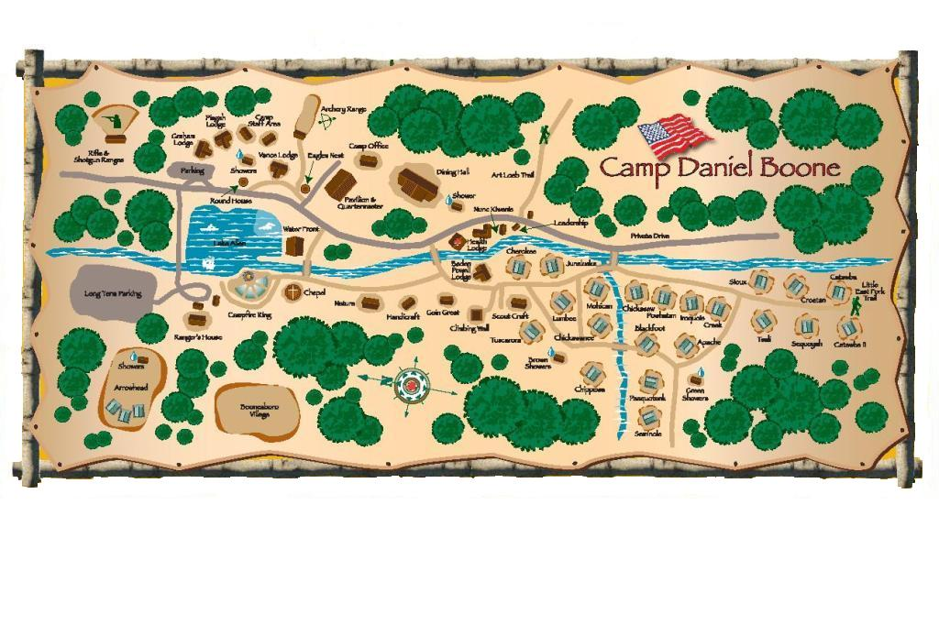

**Other Info:**

* Bag dinner for Friday evening.
* Lunch will be provided for Monday prior to returning for home.
* Backpacks are required for all treks. Everyone should bring and prepare their own food for all meals except Monday lunch.
* Wilderness Area etiquette:
  + No fires allowed within the Wilderness Area boundaries. Fires are allowed in Pisgah NF.
  + Bear canisters are required for food storage
  + Bear canisters will be provided by the troop, but are limited. Do not bring excess food. Scouts/leaders should only have food they plan to eat Monday morning left over after Sunday night. All scented toiletries (toothpaste, etc.) must fit into the bear canisters. ABSOLUTELY NO FOOD IN TENTS!
* Packing list is on the Troop website. Pay attention to the weather forecasts. Most groups will be camping at 5000-6000’ elevation which can range to 15+ degrees cooler and much windier than Winston-Salem, particularly at night and early morning.

